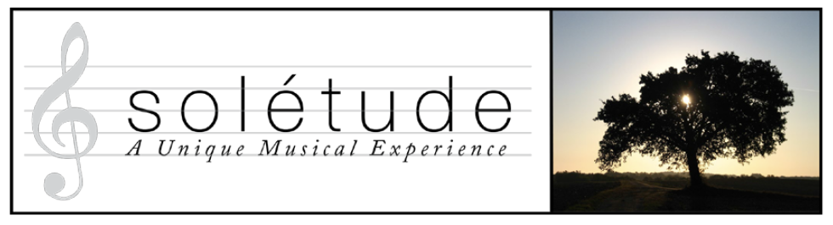 | Application Form
BOOKING FORM Please fill in a separate form for each applicant and for each course .
Arrival for all courses is on the afternoon or early evening of the first day, and departure is mid to late morning of the final day. Please check that travel to La Ville is feasible before you book your course. A confirmation email for your course enrolment will be sent to you within 3 working days. If you have any questions about either the courses or the enrolment form please contact us. Please fill in all sections.

Your Information
Full Name: |  |  |  | Date:
 | Last | First | .

Address:

Street Address

 | City |  | Postcode

Phone: |  | Email

Your Age Range: (18-31 / 31-50 / 50-65 / 65-75 / 76+)

Your Course

Please enter the name of the the course you are interested in:
Course Name:

.
Current list Of Courses:

Choral Course 1 I Can Sing A Rainbow. | Choral Course 2 If Music Be The Food Of Love
Choral Workshop 1 | Choral Workshop 2 | Piano Teacher Development Course | Piano For Adult Learners 1
Piano For Adult Learners 2

Your Accommodation

Please enter your choice of accommodation:
Accommodation Preference:

List Of Options:  Non Residential |  |  | Shared Twin
Single Room |  |  | Non Participant In Shared Room
Double Room

If sharing with whom:

More Information

Please give a little information about your musical experience, which is relevant to your chosen course:

Do you have any special dietary needs or allergies?:

Do you have any health issues that would be helpful for us to know about?:

How did you hear about Soletude?:

Are you happy for your image to be used in publicity materials?:

Yes / No:

Have you read and agreed to the terms & conditions?
(we cannot process your application without a YES)

Yes / No:

Soletude undertakes never to share your information with other organisations.

Once you have completed the form please save with guests name and email the form to us at:
soletude@yahoo.com

